|  |  |
| --- | --- |
| **New Hampshire Astronomical Sites for Public Viewing Opportunities** | |
| 1 | [Keene Amateur Astronomers](http://www.keeneastronomy.org/) |
| 2 | [Mark Sylvestre Planetarium](https://campus.plymouth.edu/asc/planetarium/) |
| 3 | [McAuliffe-Shepard Discovery Center](https://www.starhop.com/home.htm) |
| 4 | [New Hampshire Astronomical Society](http://nhastro.com/) |
| 5 | [Perkin Observatory](https://www.dublinschool.org/astro) |
| 6 | [Phillips Exeter Academy Astronomy](https://exeterastro.com/) |
| 7 | [Shattuck at Dartmouth](https://www.go-astronomy.com/observatory.php?ID=183) |
| 8 | [UNH at Durham Observatory](https://physics.unh.edu/content/observatory) |

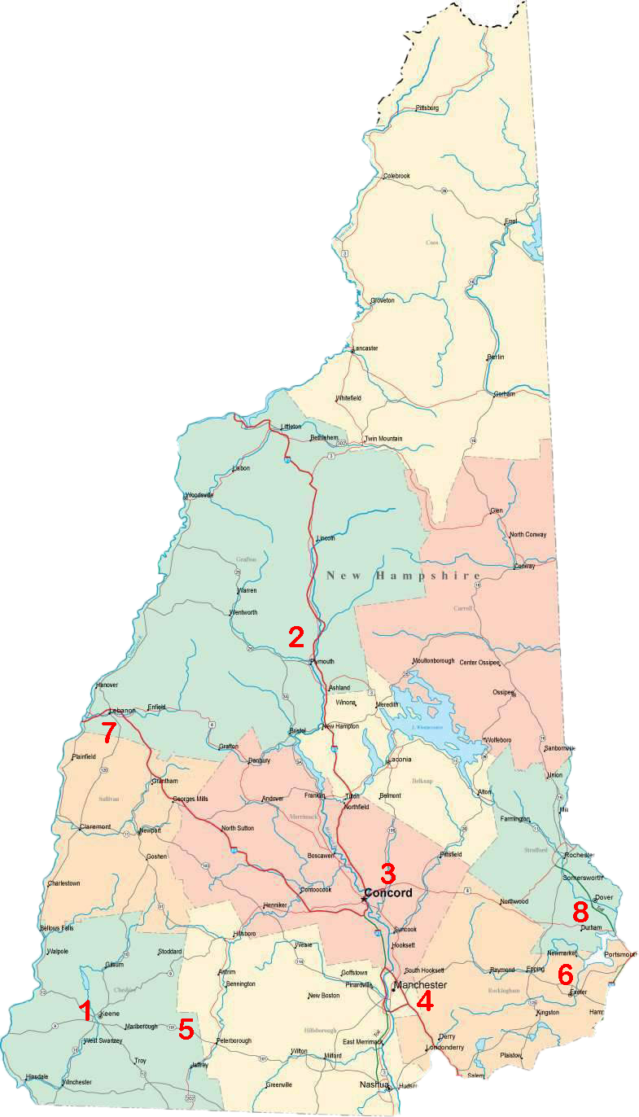­­

J.H.Faux  
11.19.2019